Ex.no:6 | DATA VISUALIZATION USING POWER BI

Aim:
To Load the data into PowerBI and transform the data and visualize it to get insights

Algorithm:

Algorithm: Sales Dashboard Calculation
Step 1: Input Data Loading
- Load the dataset containing columns: Site Name, Accessibility, Tourist Rating, Satisfaction, and Tourist ID.
- Total rows: 5,000.
Step 2: Region Filter Check
- Filter Dimension: Accessibility
- Default Selection: (All) $\rightarrow$ True, False
- Retain all rows matching the active slicer/filter selection in Filtered_Data.
Step 3: KPI Total Sales Calculation
Compute high-level headline summary values across Filtered_Data:
- Total Tourists (N): Count of distinct Tourist ID
- Total Tourists = CountDistinct(Tourist ID) = 5,000
- Average Tourist Rating (R):
- R = sum(Tourist Rating)/N= 3.00
- Average Satisfaction Score (S):
Step 4: Bar Chart Calculation (Sum of Sales by Product)
- Group Filtered_Data by Site Name and compute the average metric:
- Machu Picchu: 3.02
- Eiffel Tower: 3.02
- Great Wall of China: 3.00
- Colosseum: 2.99
- Taj Mahal:2.98
Sort sites in descending order of performance/rating.
Step 5: Donut Chart Calculation (Sum of Sales by Region)
- Group Filtered_Data by Accessibility and compute visitor count per category:
- False (Non-Accessible): 2,531 records
- Share =( 2531/5000) x 100 = 50.62%
- True (Accessible): 2,469 records
- Share = (2469/5000)x100 = 49.38%
- Total percentage sum: 50.62% + 49.38% = 100.00%
Step 6: Dashboard Render
- KPI Header Card: Display total tourist count (5,000), average rating (3.00), and satisfaction metric.
- Bar Chart: Render horizontal or vertical bars for each of the 5 heritage sites sorted by rating.
- Pie/Donut Chart: Render split slices for True (49.38%) vs False (50.62%).
- Interactive Filter: Render checkbox control for Accessibility (All, True, False).
- Dynamic Recompute: When a user selects True or False in the filter, recompute Steps 2 through 6 dynamically across all visual cards.

Output:
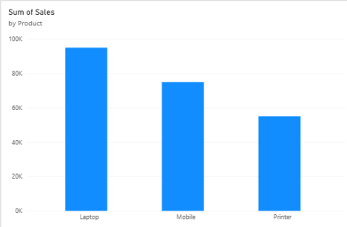
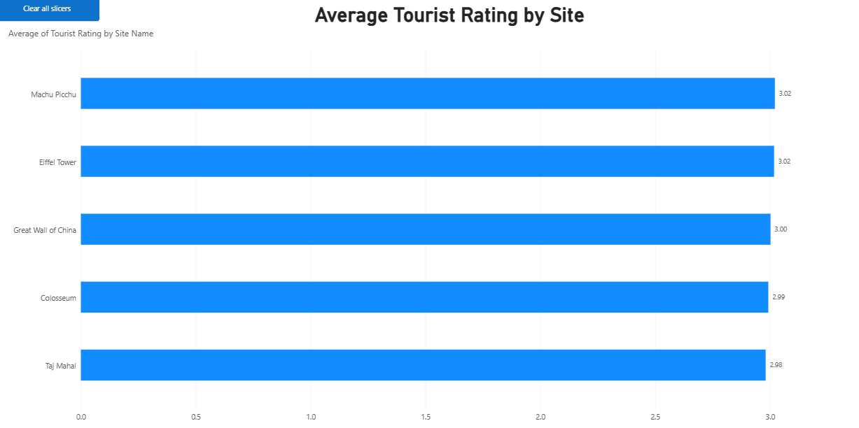

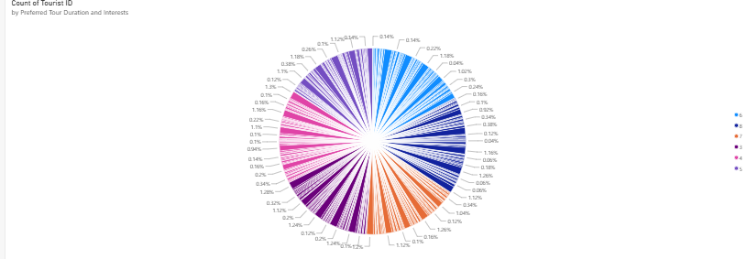

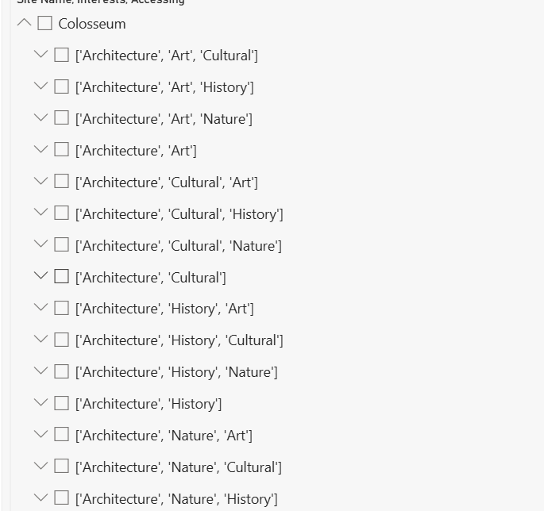

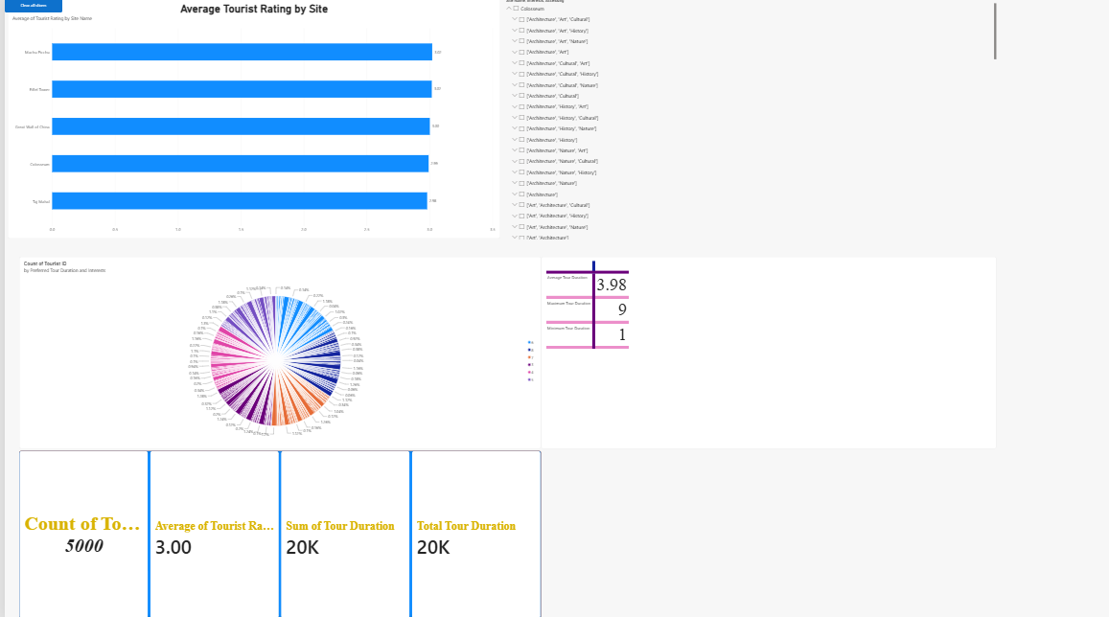

Result:

